**POINT OF SALES ARCHITECTURE.**

**Sequence Diagram.**

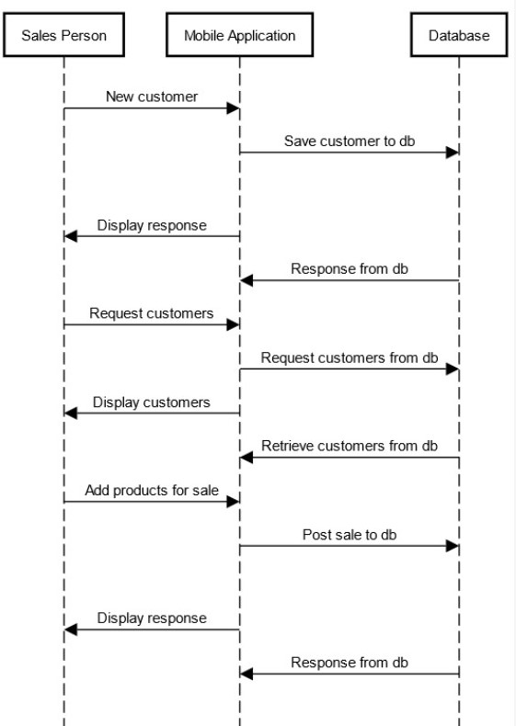

**Component Diagram.**

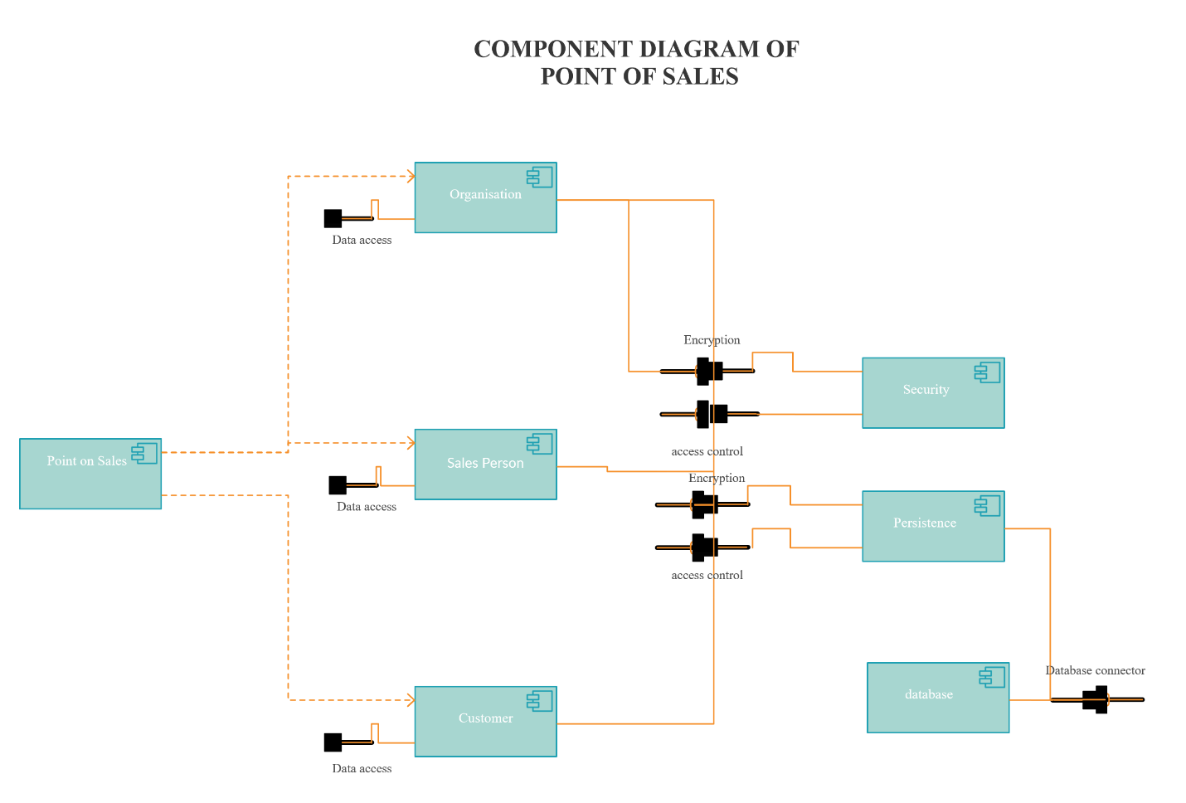

**Use Cases.**

The point of sales system is used by sales people to merchandise a range of gas accessories which include gas refill, burners, cookers, lantern etc.

The following are the use cases.

**Manage Customers:** Sales people move around the selected region with the gas accessories prospecting customers. New customer is on-boarded onto the system together with details like phone number and shop name. Customer geocodes are picked and are used to limit sale radius and also for route planning. Sales are limited to customer premises using geo-fence. Sales person is restricted to a route and must attend to all the customers along the route. In case of no sale, sales person is required to raise ticket and the customer is released from the list.

**Manage Sales:** Upon reaching the customer premise, sales person add products to cart. The system does the calculation and in case of discount, it will compute appropriately. The sales person should then select the payment methods which are attached to the customers. Multiple payment methods is accepted so the total amount will be distributed among the selected payment methods. After this the sale is submitted.